EXPT NO: 7 | OVER-PLOTTING REDUCTION TECHNIQUES
DATE: 09.02.2026 | OVER-PLOTTING REDUCTION TECHNIQUES

PRE-LAB QUESTIONS
1. Why is over-plotting common in big data visualization?
Because millions of data points are mapped onto limited screen pixels, causing points to overlap.
2. How does data density affect perception?
High density makes patterns hard to see and hides clusters or outliers from human perception.
3. What trade-offs exist between detail and clarity?
More detail increases clutter, while more clarity requires summarizing or simplifying data.
4. How do AI datasets increase visualization complexity?
AI datasets are large, high-dimensional, and noisy, making simple visualizations insufficient.
5. Why is over-plotting a serious analytical risk?
It hides real trends and can lead to incorrect interpretations and decisions.

OBJECTIVE : To apply techniques that reduce visual clutter in large-scale datasets.

SCENARIO A social media analytics company visualizes millions of user interactions to study engagement patterns.

IN-LAB TASKS (Using R Language) • Apply alpha blending • Implement jittering techniques • Use aggregation and binning

CODE :
# STEP 1: Rename the already loaded dataset to a proper variable
df <- `7.social_media_interactions`
# STEP 2: Verify structure
str(df)
# STEP 3: Basic scatter plot to show overplotting problem
plot(df$Likes, df$Comments,
main="Raw Plot - Overplotting",
xlab="Likes",
ylab="Comments")
# STEP 4: Alpha Blending Technique
plot(df$Likes, df$Comments,
col=rgb(0,0,1,0.1),
pch=16,
main="Alpha Blending Technique",
xlab="Likes",
ylab="Comments")
# STEP 5: Jittering Technique
plot(jitter(df$Likes), jitter(df$Comments),
col=rgb(1,0,0,0.2),
pch=16,
main="Jittering Technique",
xlab="Likes",
ylab="Comments")
# STEP 6: Install and load hexbin package (only if not installed)
if(!require(hexbin)) {
install.packages("hexbin")
library(hexbin)
}
# STEP 7: Hexbin Aggregation Technique
hb <- hexbin(df$Likes, df$Comments)
plot(hb,
main="Hexbin Aggregation - Social Media Data",
xlab="Likes",
ylab="Comments")
# STEP 8: Display Roll Number (optional as per lab format)
my_roll_no <- "23BAD109"
print(paste("Lab completed by roll number:", my_roll_no))

OUTPUT:

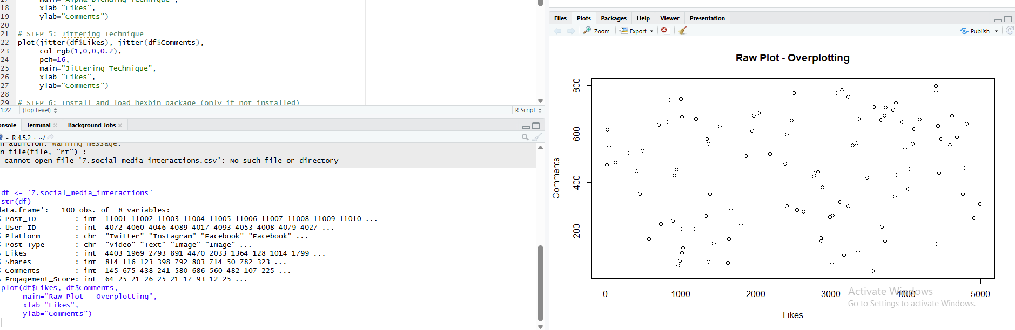

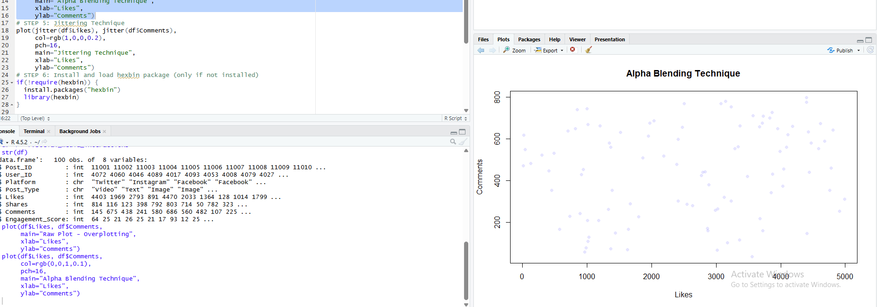

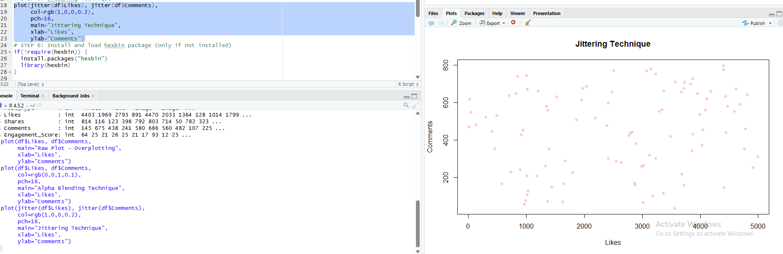

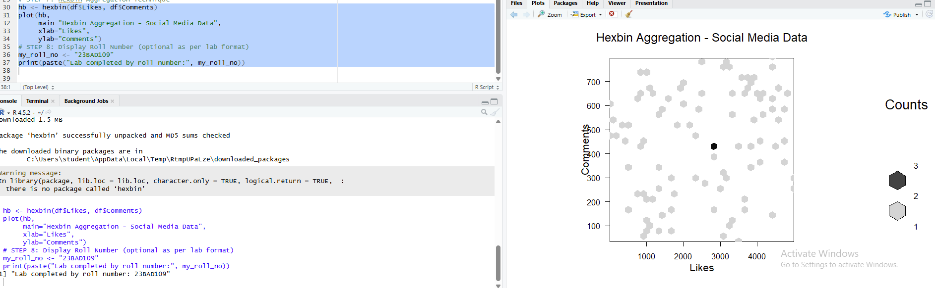

Gitlink: https://github.com/Shamini-tech/23BAD109_U18AII5202_/tree/main/EX-7%20IMPLEMENT%20OVER%20PLOTTING

POST-LAB QUESTIONS
1. Which technique provided the best clarity and why?
Aggregation/binning gave the best clarity because it summarizes density instead of plotting every point.
2. How does over-plotting distort analytical conclusions?
It hides patterns, clusters, and outliers, leading to false or misleading insights.
3. When should aggregation be preferred over raw plotting?
When the dataset is large and individual points are less important than overall trends.
4. How do these techniques support scalable AI analytics?
They allow visualization of massive datasets without clutter, enabling better model analysis.
5. Explain real-world consequences of ignoring over-plotting.
It can cause wrong business or AI decisions due to misinterpreted data patterns.

LEARNING OUTCOME: Students master over-plotting reduction for big data visual analytics.
ASSESSMENT
Description | Max Marks | Marks Awarded
Pre Lab Exercise | 5
In Lab Exercise | 10
Post Lab Exercise | 5
Viva | 10
Total | 30
Faculty Signature

